5-KURSANTLAR VZVODI SHAXSIY TARKIBINING
RO‘YXATI
T/R | F.I.SH | Passport (PNEL)  JSHSHIR | Rasm 3x4 | Bo‘linmasi
 | Sadullayev Mirjalol Farhodovich | 30608921040029 | 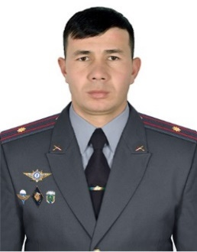 | 3-batalyon  komandiri
 | Usmonov Feruzjon Muxiddinovich | 30088247314048 | 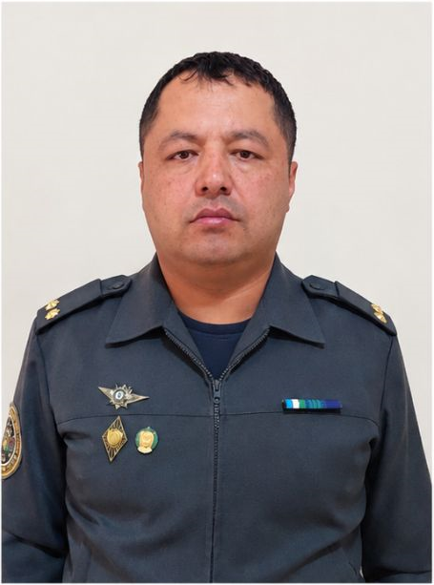 | 3-batalyon  komandirining T va MIBO‘
 | Abdusalomov Zuhriddin Abduvali o‘g‘li | 31209932560169 | 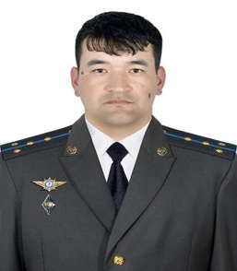 | 3-batalyon  5-vzvod komandiri
 | Janobiddinov Ahliddin Shahobiddin o‘g‘li | 31204975970016 |  | 3-batalyon  5-vzvod 1-guruh komandiri
 | Bahriddinov Azizbek Zuhriddin o'g‘li | 52208077000045 | 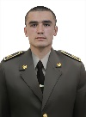 | 3-batalyon  5-vzvod  1-guruh
 | Begimqulov Baxtishod Shuhrat o‘g‘li | 51510065630028 | 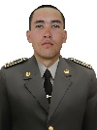 | 3-batalyon  5-vzvod  1-guruh
 | Bog'ibekov Javohir O‘ktam o‘g‘li | 51704067310079 | 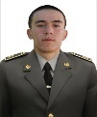 | 3-batalyon  5-vzvod  1-guruh
 | Eshmurodov Sardor Bekmurod o‘g‘1i | 50809066070030 | 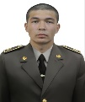 | 3-batalyon  5-vzvod  1-guruh
 | Joldasov Bag‘lanbek Baxitbekovich | 52905066810031 | 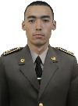 | 3-batalyon  5-vzvod  1-guruh
 | Mamatojiyev Asadbek Akmaljon o‘g‘li | 52210066960025 | 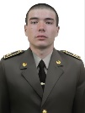 | 3-batalyon  5-vzvod  1-guruh
 | Narzullayev Asilbek Ilxomjon o‘g‘li | 51306066090110 | 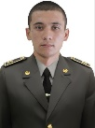 | 3-batalyon  5-vzvod  1-guruh
 | O‘ralov Shahzodjon Sherali o'g‘li | 51708065440046 | 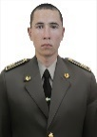 | 3-batalyon  5-vzvod  1-guruh
 | Qurbonov Abdulla llxom o'g‘li | 52705065650025 | 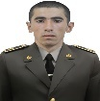 | 3-batalyon  5-vzvod  1-guruh
 | Risboyev Dilshodbek Oybek o‘g‘li | 51103066450021 | 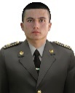 | 3-batalyon  5-vzvod  1-guruh
 | Ruziboyev Bektosh Burxonjonovich | 50802066100024 | 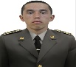 | 3-batalyon  5-vzvod  1-guruh
 | Sadiyev Izzatillo Akmal o‘g‘li | 52612065330018 | 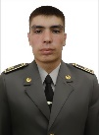 | 3-batalyon  5-vzvod  1-guruh
 | Salimov Bahodir Yorqin o‘g‘li | 52502065910043 |  | 3-batalyon  5-vzvod  1-guruh
 | Samadov Sirojbek Sohibjon o‘g‘li | 53105065310052 | 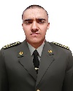 | 3-batalyon  5-vzvod  1-guruh
 | Sohibov Obidjon Vohid o‘g‘li | 51002075330041 | 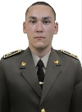 | 3-batalyon  5-vzvod  1-guruh
 | To‘rayev Shamshod Zayniddinovich | 51207075270013 | 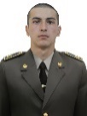 | 3-batalyon  5-vzvod  1-guruh
 | Toshpulatov Qosimjon Yoqubjon o‘g‘li | 51912065650084 | 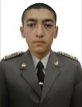 | 3-batalyon  5-vzvod  1-guruh
 | Xayrulloyev Rustamjon Elyor o'g‘li | 52510065310079 | 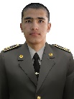 | 3-batalyon  5-vzvod  1-guruh
 | Xolmurodov Hamza Elyor o‘g‘li | 50405055350026 | 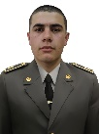 | 3-batalyon  5-vzvod  1-guruh
 | Ziyodulloyev Sardorbek Zafarbek o‘g‘li | 51411065310047 | 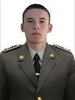 | 3-batalyon  5-vzvod  1-guruh
 | Nazarov Zuhriddin Faxriddin o‘g‘li | 31106922720072 | 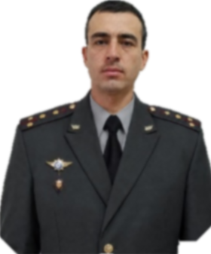 | 3-batalyon  5-vzvod  2-guruh komandiri
 | Abdujalilov Fazliddin Botirali o‘g‘li | 50507066810068 | 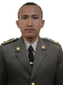 | 3-batalyon  5-vzvod  2-guruh
 | Abdumuxtorov Ilyosbek Iqboljon og‘li | 52405056930010 | 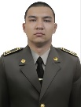 | 3-batalyon  5-vzvod  2-guruh
 | Berdiyev Hayitbek Mavlonberdiyevich | 51001065320050 | 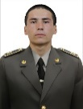 | 3-batalyon  5-vzvod  2-guruh
 | Hasanov Azizbek Abdug‘ani o‘g‘li | 50912055900044 | 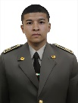 | 3-batalyon  5-vzvod  2-guruh
 | Jo‘ramurodov Laziz Xusniddinovich | 51702066310018 | 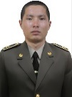 | 3-batalyon  5-vzvod  2-guruh
 | Jo‘rayev Sherali Jalol o‘g‘li | 52206065720117 | 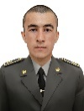 | 3-batalyon  5-vzvod  2-guruh
 | Kucharov Shohjahon Norbobo o‘g‘li | 53004046050052 | 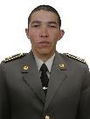 | 3-batalyon  5-vzvod  2-guruh
 | Mardiyev Ozodbek Muhiddin o‘g‘li | 52009066070052 | 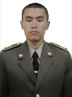 | 3-batalyon  5-vzvod  2-guruh
 | Muzaffarov Temurmalik Muxtor o‘g‘li | 51204065310047 | 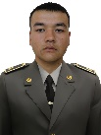 | 3-batalyon  5-vzvod  2-guruh
 | Nabijonov Xojiakbar Valijon o‘g‘li | 50901076940032 | 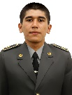 | 3-batalyon  5-vzvod  2-guruh
 | Nematov Nusrat Furqat o‘g‘li | 51107065310021 |  | 3-batalyon  5-vzvod  2-guruh
 | Ro‘ziqulov Fozilbek Toirovich | 50507055320015 | 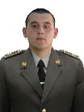 | 3-batalyon  5-vzvod  2-guruh
 | Sadullayev Jasurbek Mansur o‘g‘li | 52807067350025 | 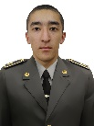 | 3-batalyon  5-vzvod  2-guruh
 | Saliev Ramazan Amin o‘gli | 50610057360054 | 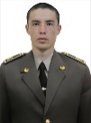 | 3-batalyon  5-vzvod  2-guruh
 | Shomurodov Xushnudbek O‘tkir o‘g‘li | 53004065730032 | 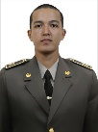 | 3-batalyon  5-vzvod  2-guruh
 | Sirojiddinov Zuhriddin Sirojiddin o‘g‘li | 50308065210053 | 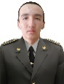 | 3-batalyon  5-vzvod  2-guruh
 | Sunnatilloyev Navro‘z Sayfiddin o‘g‘li | 52003065310045 | 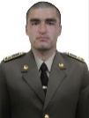 | 3-batalyon  5-vzvod  2-guruh
 | Xolmatov Jasurbek G'ayrat o'g‘li | 52406066710052 | 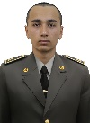 | 3-batalyon  5-vzvod  2-guruh
 | Yusufjonov Ziyobek Adhamjon o‘g‘li | 50510065910017 | 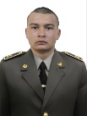 | 3-batalyon  5-vzvod  2-guruh
 | Yusupov Omonullo Panji o‘g'li | 52310055630025 | 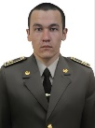 | 3-batalyon  5-vzvod  2-guruh
 | Abduqodirov Bahodirjon Jahongiro‘g‘li | 50301076960030 | 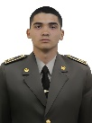 | 3-batalyon  5-vzvod  3-guruh
 | Absalimov Xushnudbek Davron o‘g‘li | 50507065730013 | 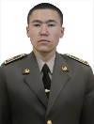 | 3-batalyon  5-vzvod  3-guruh
 | Buriyev Javohir Oydin o‘g‘li | 51706065830023 | 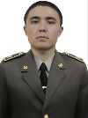 | 3-batalyon  5-vzvod  3-guruh
 | Halimov Sobirjon Jasurjonovich | 50308055320030 | 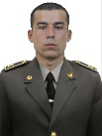 | 3-batalyon  5-vzvod  3-guruh
 | Hamidullayev Rahmatullo Ubaydullo o‘g‘li | 52101067060048 | 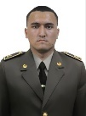 | 3-batalyon  5-vzvod  3-guruh
 | Ismatullayev Azizbek To‘lqin o‘g‘li | 50109066230176 | 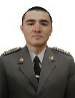 | 3-batalyon  5-vzvod  3-guruh
 | Itolmasov Sh  axriyor Lazizovich | 50806065270016 | 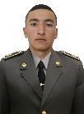 | 3-batalyon  5-vzvod  3-guruh
 | Janabaev Nurbol Kurmangazi o‘g‘li | 50601077360078 | 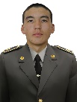 | 3-batalyon  5-vzvod  3-guruh
 | Jo‘ravoyev Jahongir Faruxjon o‘g‘li | 50912055970050 | 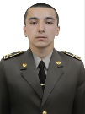 | 3-batalyon  5-vzvod  3-guruh
 | O‘razmatov Lazizbek Davronbek o‘g‘li | 50110067230030 | 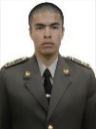 | 3-batalyon  5-vzvod  3-guruh
 | Panjiyev Feruz Qodir o‘g‘li | 52208065630056 | 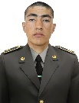 | 3-batalyon  5-vzvod  3-guruh
 | Risqulov Abror Shermamat o‘g‘li | 52701066450024 | 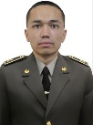 | 3-batalyon  5-vzvod  3-guruh
 | Ro‘ziyev Ozodbek Shukrullo o‘g‘li | 50207065350065 | 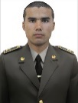 | 3-batalyon  5-vzvod  3-guruh
 | Saitburxanov Joxongirmirzo Muxammadali o‘g‘li | 51611055890012 | 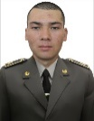 | 3-batalyon  5-vzvod  3-guruh
 | Salimboyev Ozodbek Nabiyevich | 50305065320014 | 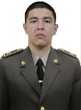 | 3-batalyon  5-vzvod  3-guruh
 | Ummatov Asliddin Botirbek o‘g‘li | 52412035400022 | 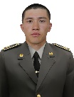 | 3-batalyon  5-vzvod  3-guruh
 | Xamidov Nurmuhammad Qobil o‘g‘li | 51102075220120 | 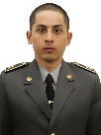 | 3-batalyon  5-vzvod  3-guruh
 | Xolmirzayev Ulug‘bek Jaxongir o‘g‘li | 51907065150063 | 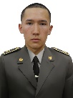 | 3-batalyon  5-vzvod  3-guruh
 | Mo‘minov Jahongir Azaijon o‘g‘li | 31201926900016 | 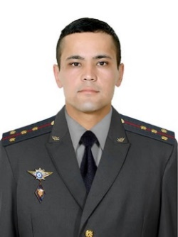 | 3-batalyon  5-vzvod  4-5-6 guruh komandiri
 | Abdiqodirov Lochinbek O‘ktam o‘g‘li | 51010065610034 | 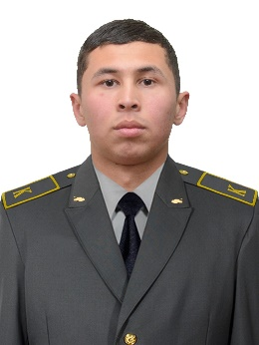 | 3-batalyon  5-vzvod  4-guruh
 | Bo‘riyev Avezbek Muzafforovich | 51406065320011 | 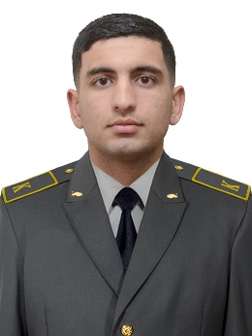 | 3-batalyon  5-vzvod  4-guruh
 | Qobulov Ibraximjon Zafar o‘g‘li | 522009046540328 | 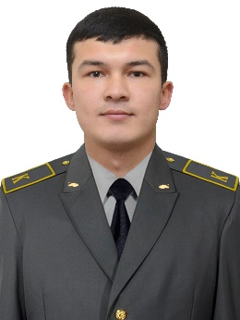 | 3-batalyon  5-vzvod  4-guruh
 | Eshquvatov Humoyun Ikrom o‘g‘li | 51912045430015 | 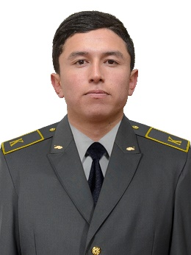 | 3-batalyon  5-vzvod  4-guruh
 | Umarov Saidbek Norbek o‘g‘li | 51407066450019 | 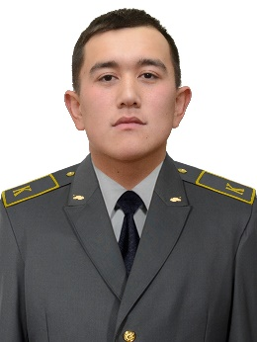 | 3-batalyon  5-vzvod  4-guruh
 | Rahmatov Hakimjon Inom o‘g‘li | 51902067030021 | 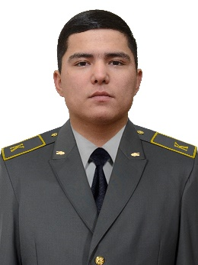 | 3-batalyon  5-vzvod  4-guruh
 | Abdujalilov Azizbek Abdubasir o‘g‘li | 90704101002140 | 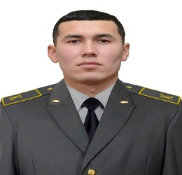 | 3-batalyon  5-vzvod  4-guruh
 | Muminov Zafarbek Fayzi o‘g‘li | 52620056300017 | 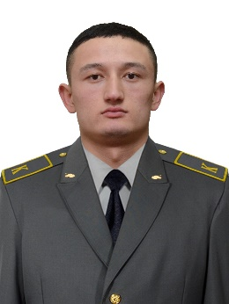 | 3-batalyon  5-vzvod  4-guruh
 | Abdumajitov Ibroximjon Turaqul o‘g‘li | 55441066100010 | 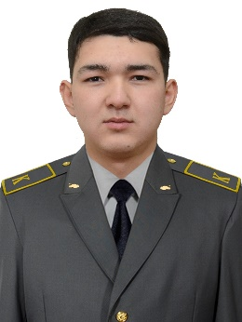 | 3-batalyon  5-vzvod  4-guruh
 | Ibadullayev Shoxrux O‘rinboy o‘g‘li | 51202065920013 | 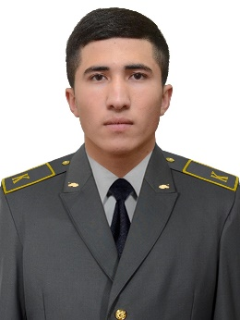 | 3-batalyon  5-vzvod  4-guruh
 | Mamanazarov Rustam Ismat o‘g‘li | 52304065590032 | 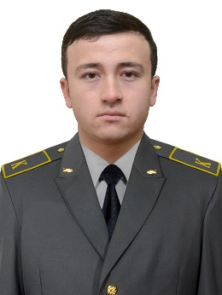 | 3-batalyon  5-vzvod  4-guruh
 | Imomaliyev Abdusattor Adash o‘g‘li | 51710066230106 | 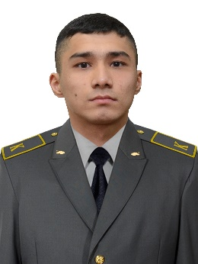 | 3-batalyon  5-vzvod  4-guruh
 | Abdullajonov Shoxjaxon Akramjon o‘g‘li | 51202065920013 | 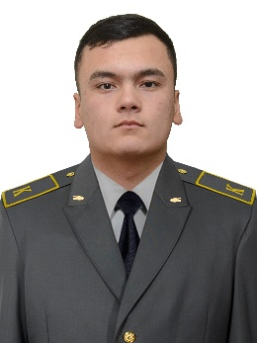 | 3-batalyon  5-vzvod  4-guruh
 | Salimov Umarjon Xudobergan o‘g‘li | 51711066950054 | 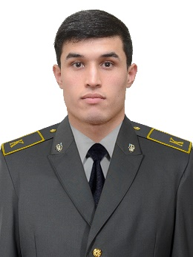 | 3-batalyon  5-vzvod  5-guruh
 | To‘xtasinov Boxodir Zafarjon o‘g‘li | 52010066960047 | 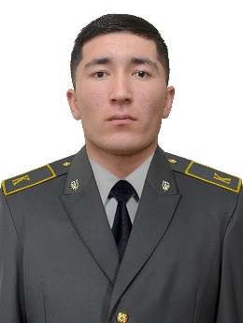 | 3-batalyon  5-vzvod  5-guruh
 | Yusufov Shohidjon Baxodirjon o‘g‘li | 52301076960029 | 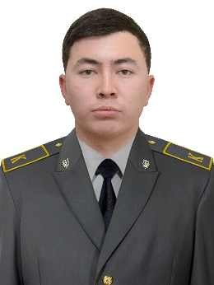 | 3-batalyon  5-vzvod  5-guruh
 | Abdumalikov Ozodbek Anvarjon o‘g‘li | 51305065700055 | 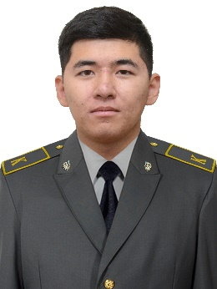 | 3-batalyon  5-vzvod  5-guruh
 | Raximov Bekzodjon Baxromali o‘g‘li | 51209065910055 | 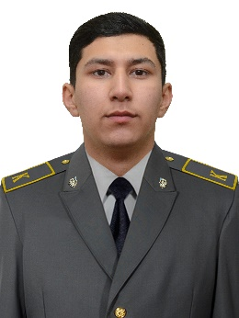 | 3-batalyon  5-vzvod  5-guruh
 | Shoberdiyev Mehroj Husan o’gli | 51305065700055 | 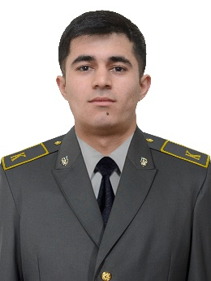 | 3-batalyon  5-vzvod  5-guruh
 | Xoliqov Boburjon Shokir o‘g‘li | 51407056330024 | 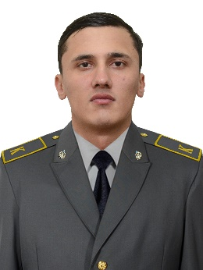 | 3-batalyon  5-vzvod  5-guruh
 | Nortojiyev Nurbek Ulug‘bek o‘g‘li | 51401075660045 | 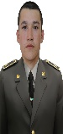 | 3-batalyon  5-vzvod  6-guruh
 | Xujanov Adhamjon Shaxobiddin o‘g‘li | 51908055730023 | 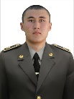 | 3-batalyon  5-vzvod  6-guruh
 | G‘aybullayev Amrillo Abror o‘g‘li | 3150793106050 | 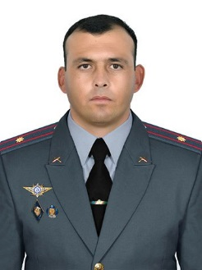 | 3-batalyon  6-kursantlar vzvodi komandiri
 | Matniyozov Islombek Mansurovich | 31901973180048 | 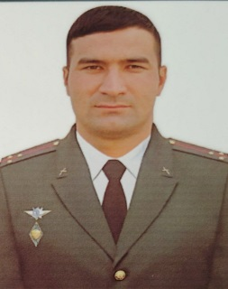 | 3-batalyon  6-kursantlar vzvodi 1-guruh komandiri
 | Tursunov Asadbek Aktam o‘g‘li | 52906066050058 | 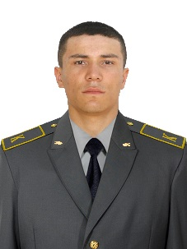 | 3 batalyon  6 vzvod  1 guruh
 | Abdumannonov Nurnazar Azamat o‘g‘li | 50302066080031 | 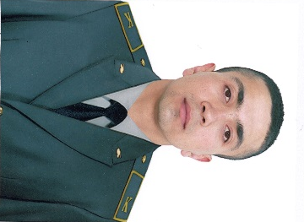 | 3 batalyon  6 vzvod  1 guruh
 | Odiljonov Samandar To‘lqin o‘g‘li | 51511065200064 | 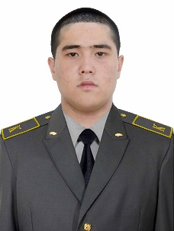 | 3 batalyon  6 vzvod  1 guruh
 | Bekmurodov Elmurod Mehriddinovich | 51608065360024 | 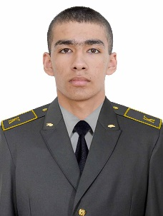 | 3 batalyon  6 vzvod  1 guruh
 | Hoshimjonov To  ‘labek Kozimjon o‘g‘li | 52011067020015 | 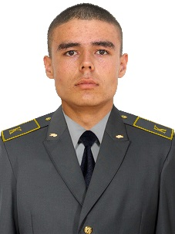 | 3 batalyon  6 vzvod  1 guruh
 | Islomov Avazbek Boboniyozovich | 51807066180042 | 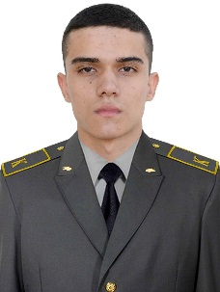 | 3 batalyon  6 vzvod  1 guruh
 | Matyazov Murodjon G‘ulomjon o‘g‘li | 50804067100023 | 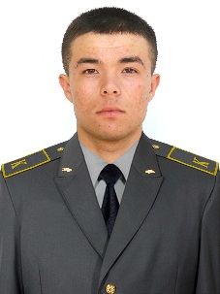 | 3 batalyon  6 vzvod  1 guruh
 | Muhammadov Ozodbek Mo‘minjon o‘g‘li | 52608066960026 | 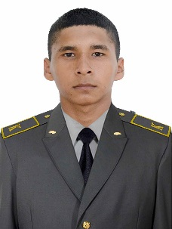 | 3 batalyon  6 vzvod  1 guruh
 | Xusenov Amur-Temur Obid o‘g‘li | 50904056020027 | 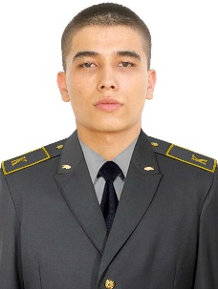 | 3 batalyon  6 vzvod  1 guruh
 | Raxmonqulov Sobirjon | 51605065440060 | 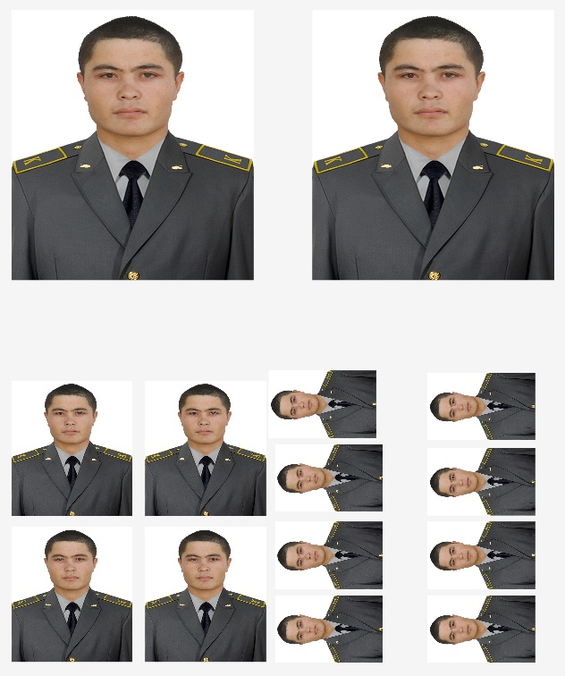 | 3 batalyon  6 vzvod  1 guruh
 | Rayimjonov Og‘abek Oybek o‘g‘li | 51905067030037 | 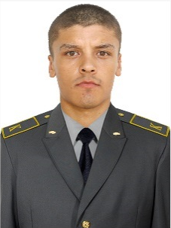 | 3 batalyon  6 vzvod  1 guruh
 | Yusufov Sohibjon Sodiq o‘g‘li | 52106066080075 | 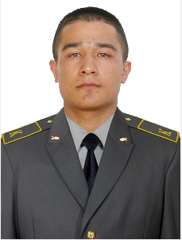 | 3 batalyon  6 vzvod  1 guruh
 | Nosirov Samandar Umidjon | 52308067020012 | 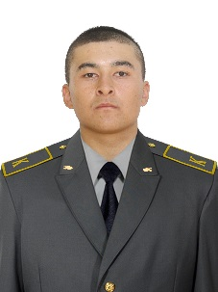 | 3 batalyon  6 vzvod  1 guruh
 | Urazbaev Gafur Rasulovich | 51807067380016 | 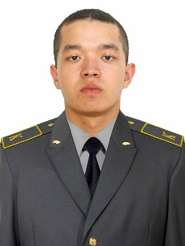 | 3 batalyon  6 vzvod  1 guruh
 | Mehriddinov Asilbek Ortiq o‘g‘li | 50404075350034 | 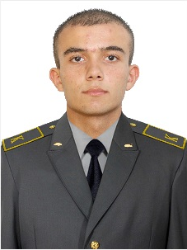 | 3 batalyon  6 vzvod  1 guruh
 | Husanov Navro’zbek Xamidjon o‘g‘li | 52103067020060 | 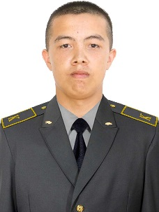 | 3 batalyon  6 vzvod  1 guruh
 | Muxtorjonov Asilbek Sardorovich | 52506055320025 | 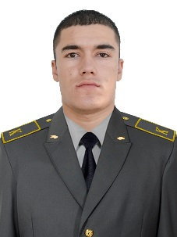 | 3 batalyon  6 vzvod  1 guruh
 | Eshniyozov Firdavs Zayniddin o‘g‘li | 50504075690036 | 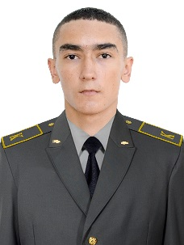 | 3 batalyon  6 vzvod  1 guruh
 | Axtamov Jonibek Islom o‘g‘li | 50908065740024 | 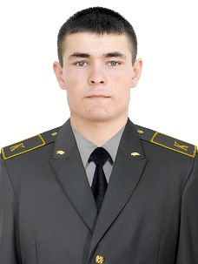 | 3 batalyon  6 vzvod  1 guruh
 | Fayzullayev Ozodbek G‘ayrat o‘g‘li | 51001065310053 | 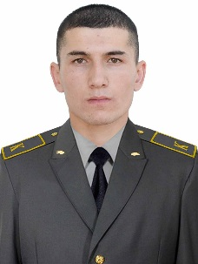 | 3 batalyon  6 vzvod  1 guruh
 | Ibragimov Nurali Sherali o‘g‘li | 52605065660021 | 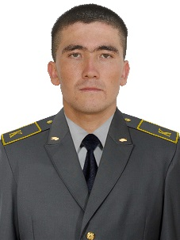 | 3 batalyon  6 vzvod  1 guruh
 | Aslanov Asror A’zam o‘g‘li | 50306075290050 | 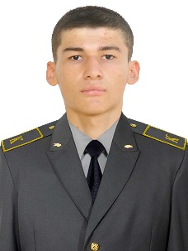 | 3 batalyon  6 vzvod  1 guruh
 | To‘xtayev Naqshband Amin o‘g‘li | 30111951060026 | 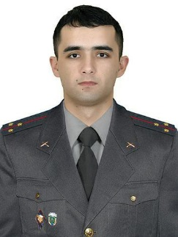 | 3-batalyon  6-kursantlar vzvodi 2-guruh komandiri
 | Turdaliyev Samandar Islomjon o‘g‘li | 51908066920073 | 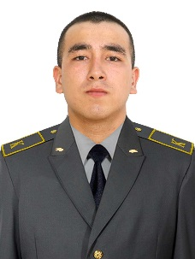 | 3 batalyon  6 vzvod  2 guruh
 | Perdebayev Erbol Ermuxambet uli | 51506067320025 | 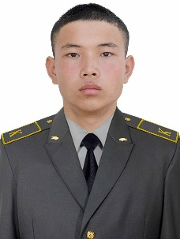 | 3 batalyon  6 vzvod  2 guruh
 | Eldorov Bunyodjon Eldorovich | 53108066720055 | 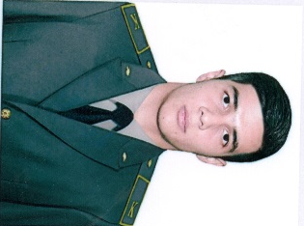 | 3 batalyon  6 vzvod  2 guruh
 | Haydarov Dostobek Davlatjon o‘g‘li | 51706066930027 | 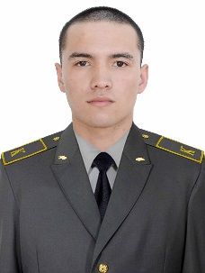 | 3 batalyon  6 vzvod  2 guruh
 | To‘xtayev Komiljon To‘lqin o‘g‘li | 51004066300027 | 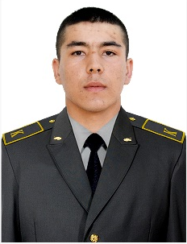 | 3 batalyon  6 vzvod  2 guruh
 | Abduraxmonov Akobir Afzal o‘g‘li | 52410055350017 |  | 3 batalyon  6 vzvod  2 guruh
 | Maxmudov Xasanboy Muxammadjon o‘g‘li | 51512045110069 | 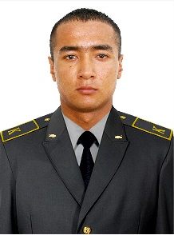 | 3 batalyon  6 vzvod  2 guruh
 | Bobomurodov Og‘abek Zokir o‘g‘li | 50406065610052 | 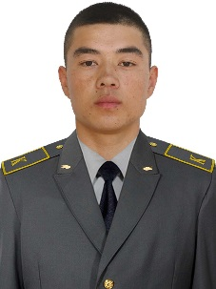 | 3 batalyon  6 vzvod  2 guruh
 | Aqmonov Inomjon G‘ulomjon o‘g‘li | 52802067110034 | 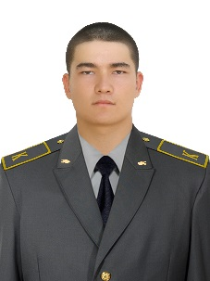 | 3 batalyon  6 vzvod  2 guruh
 | Safarboyev Jura’tbek Murodbek | 50212047120042 | 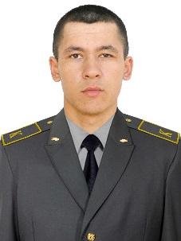 | 3 batalyon  6 vzvod  2 guruh
 | Toshkentov Islom Murod o‘g‘li | 5151005530021 | 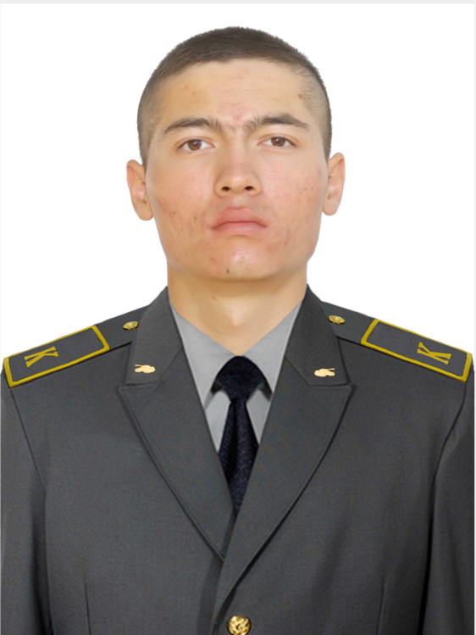 | 3 batalyon  6 vzvod  2 guruh
 | Komilov Amirbek Rasul o‘g‘li | 51104037150054 | 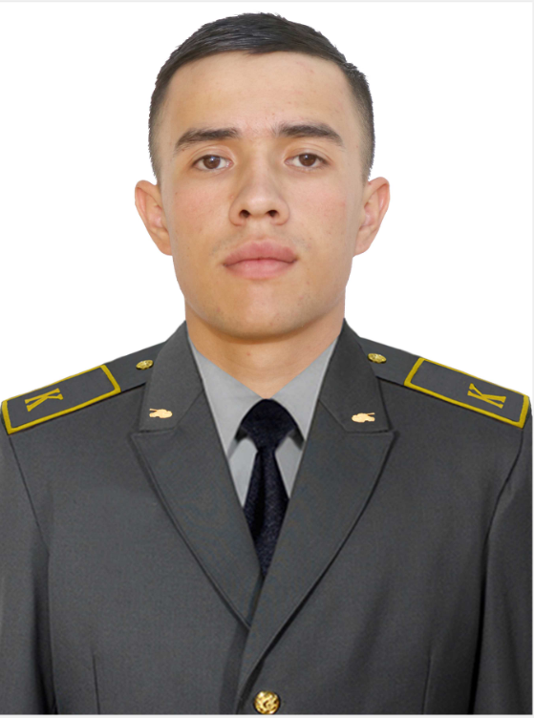 | 3 batalyon  6 vzvod  2 guruh
 | Abdulhaqov Begzodjon Ilhomjon o‘g‘li | 52409066910015 | 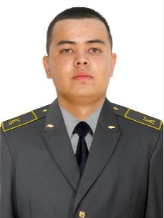 | 3 batalyon  6 vzvod  2 guruh
 | Toshev Abdurashid Ravshan o‘g‘li | 52812015310035 | 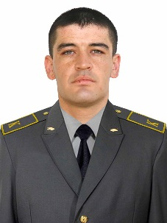 | 3 batalyon  6 vzvod  2 guruh
 | Abduxamidov Akbarjon Aalimardon o‘g‘li | 52912067020031 | 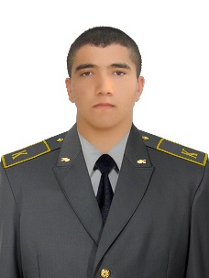 | 3 batalyon  6 vzvod  2 guruh
 | Eshquvatov Boboraxim Ne’matjon o‘g‘li | 51303065430019 | 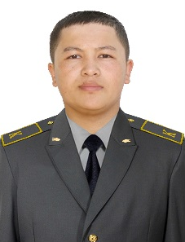 | 3 batalyon  6 vzvod  2 guruh
 | Baxtiyarov Salamat Ramat uli | 51505067340033 | 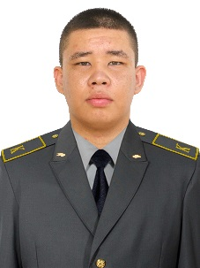 | 3 batalyon  6 vzvod  2 guruh
 | Isaqov Xasanboy Xayrulla o‘g‘li | 51905065110038 | 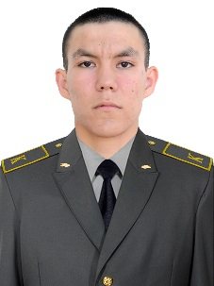 | 3 batalyon  6 vzvod  2 guruh
 | Abdujaborov Muzaffar Abdujalilovich | 51908046710056 | 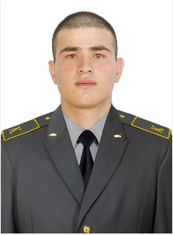 | 3 batalyon  6 vzvod  2 guruh
 | Sultonov Shahrioy Zavqiddin o‘g‘li | 51906065800017 | 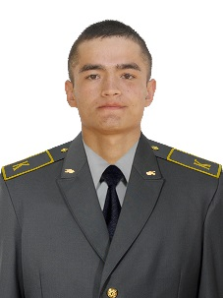 | 3 batalyon  6 vzvod  2 guruh
 | Axmadjonov Oybek Avazbek o‘g‘li | 50912065990020 | 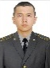 | 3 batalyon  6 vzvod  2 guruh
 | Xamidullayev Axmadullo Shavkatjon o‘g‘li | 52610045920017 | 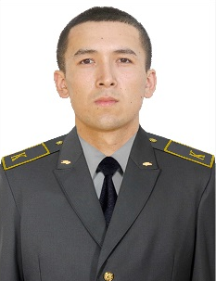 | 3 batalyon  6 vzvod  2 guruh
 | Saqidqulov Zaxriddin Asror o‘g‘li | 52103065430034 | 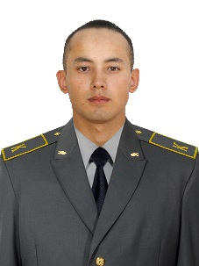 | 3 batalyon  6 vzvod  2 guruh
 | Maxmarajabov Toxir Nurumqul o‘g‘li | 31111933990020 | 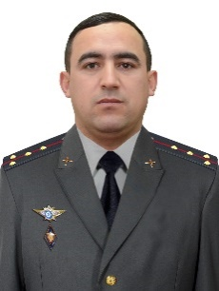 | 3-batalyon  6-kursantlar vzvodi 3-guruh komandiri
 | Abduboqiyev Azizbek Abdulfayz o‘g‘li | 51601066260025 | 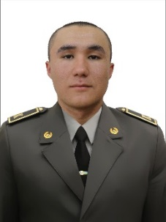 | 3 batalyon  6 vzvod  3 guruh
 | Abirqulov Abdulaziz Asqarjon o‘g‘li | 50111066420011 | 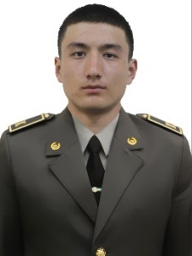 | 3 batalyon  6 vzvod  3 guruh
 | Abrayev Zafar Abdujabbor o‘g‘li | 51004066270049 | 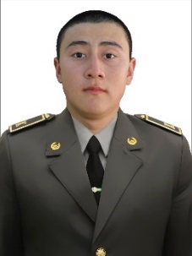 | 3 batalyon  6 vzvod  3 guruh
 | Berdiyev Jayxunbek Elmurod o‘g‘li | 52411067210052 | 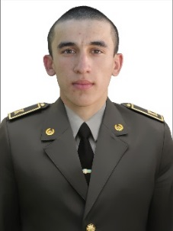 | 3 batalyon  6 vzvod  3 guruh
 | Berdiyorov Jumaniyoz Jontemir o‘g‘li | 50505065720010 | 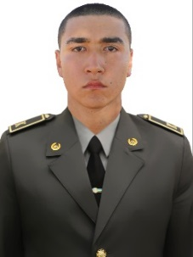 | 3 batalyon  6 vzvod  3 guruh
 | Beshimov Ma’rufjon Iskandar o‘g‘li | 51201075710018 | 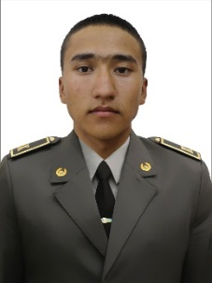 | 3 batalyon  6 vzvod  3 guruh
 | Dusmurodov Aslbek Raxmatillo o‘g‘li | 50104066170039 | 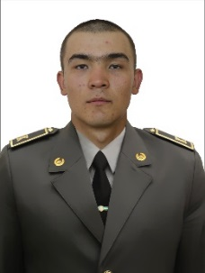 | 3 batalyon  6 vzvod  3 guruh
 | Isabekov Bunyodbek G‘ulomjon o‘g‘li | 51809065540034 | 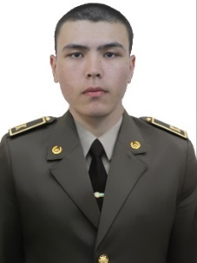 | 3 batalyon  6 vzvod  3 guruh
 | Ismoilov Asliddin Zo‘xridin o‘g‘li | 52708065080012 | 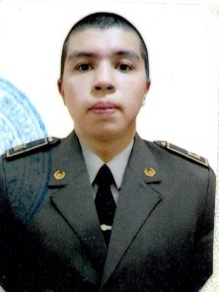 | 3 batalyon  6 vzvod  3 guruh
 | Mamadillayev Dostonjon Bekzod o‘g‘li | 50807056080065 | 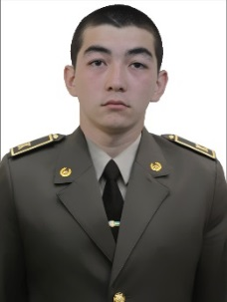 | 3 batalyon  6 vzvod  3 guruh
 | Mamarajabov Behruzbek Abiyirqul o‘g‘li | 50512065430067 | 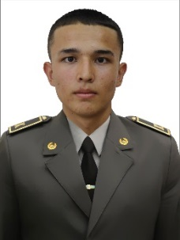 | 3 batalyon  6 vzvod  3 guruh
 | Maxmudov Bobur Voxidjon o‘g‘li | 51906066930043 | 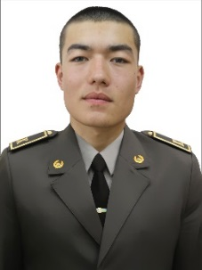 | 3 batalyon  6 vzvod  3 guruh
 | Nabiyev Juma Jo‘rabek o‘g‘li | 50601066220017 | 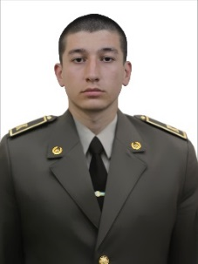 | 3 batalyon  6 vzvod  3 guruh
 | Nosirov Doniyorbek Nurmamat o‘g‘li | 50204066220036 | 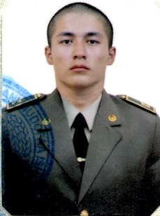 | 3 batalyon  6 vzvod  3 guruh
 | Nurmahmatov Shahbozjon Boyburi o‘g‘li | 52403066240042 | 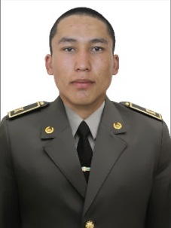 | 3 batalyon  6 vzvod  3 guruh
 | Panjivev Sunnatilla Bobir o‘g‘li | 52005066270014 | 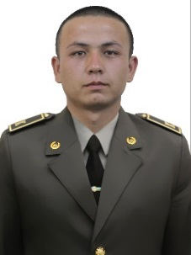 | 3 batalyon  6 vzvod  3 guruh
 | Pardayev Samandar Turaxon o‘g‘li | 52304066240044 | 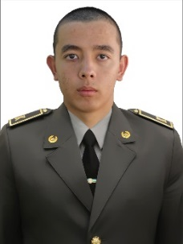 | 3 batalyon  6 vzvod  3 guruh
 | Shavkatov Abdulazizbek Azizbek o‘g‘li | 52305075200043 | 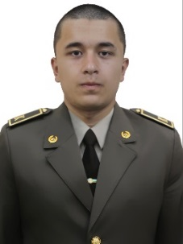 | 3 batalyon  6 vzvod  3 guruh
 | To‘raqulov Quvondiq Vahobjon o‘g‘li | 51908065700050 | 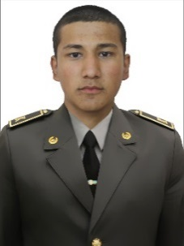 | 3 batalyon  6 vzvod  3 guruh
 | Ziyoyiddinov Ilyos Asfariddin o‘g‘li | 50411056770077 | 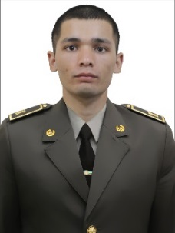 | 3 batalyon  6 vzvod  3 guruh
 | Zurobov Javohir A’zam o‘g‘li | 52002066280036 | 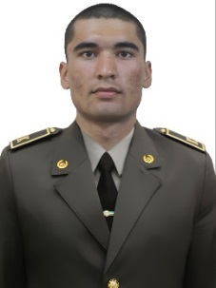 | 3 batalyon  6 vzvod  3 guruh
 | Abdujabborov Murodbek Zoxir o‘g‘li | 52501066260027 | 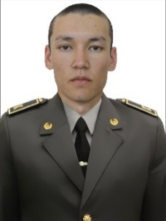 | 3 batalyon  6 vzvod  4 guruh
 | Abdunazarov O‘tkirbek Norbek o‘gii | 52112065670090 | 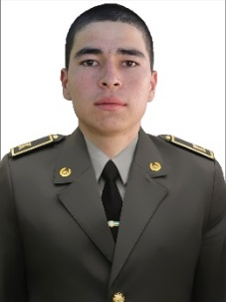 | 3 batalyon  6 vzvod  4 guruh
 | Adamboyev Karnronbek Murodbek o‘g‘li | 53101067130034 | 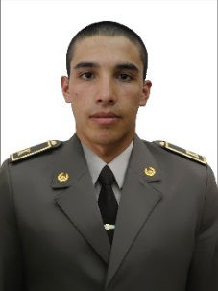 | 3 batalyon  6 vzvod  4 guruh
 | Ismoilov Ibroximjon Akramjon o‘g‘li | 50706065940011 | 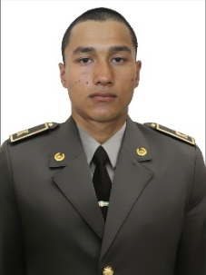 | 3 batalyon  6 vzvod  4 guruh
 | Jobborov Behruz Jobbor o‘g‘li | 51910066100050 | 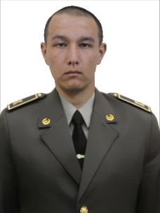 | 3 batalyon  6 vzvod  4 guruh
 | Kalknazarov Saparmurat Ilxamovich | 52102077340016 | 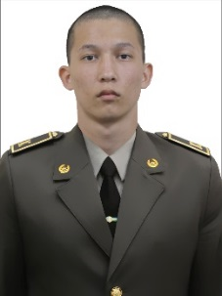 | 3 batalyon  6 vzvod  4 guruh
 | Mamasoliyev Tolibjon Kamoliddin o‘g‘li | 51201065910044 | 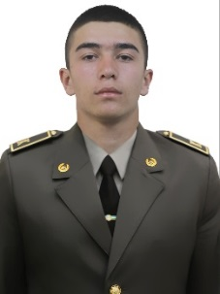 | 3 batalyon  6 vzvod  4 guruh
 | Marupov Azamat Davlatjon o‘g‘li | 52505070005012 | 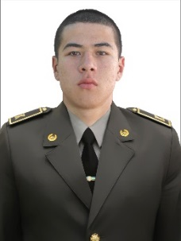 | 3 batalyon  6 vzvod  4 guruh
 | Narziqulov Murodullo Asatullo o‘g‘li | 52705066090020 | 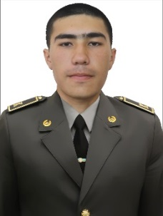 | 3 batalyon  6 vzvod  4 guruh
 | Nizomov Kamronbek Maxmud o‘g‘li | 51604065680029 | 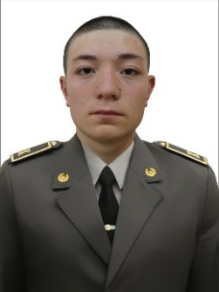 | 3 batalyon  6 vzvod  4 guruh
 | Normuminov Erkin Safarmamat o‘g‘li | 52808066330014 | 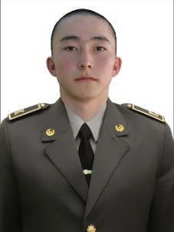 | 3 batalyon  6 vzvod  4 guruh
 | Raximov Umidjon Maxmudjon o‘g‘li | 50101065970080 | 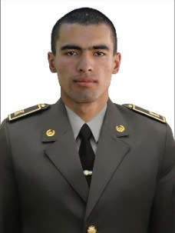 | 3 batalyon  6 vzvod  4 guruh
 | Raxmetov Komiljon San’at o‘g‘li | 51212067100014 | 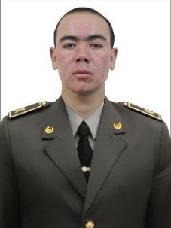 | 3 batalyon  6 vzvod  4 guruh
 | Saydullayev Lazizbek Akbar o‘g‘li | 50912065440013 | 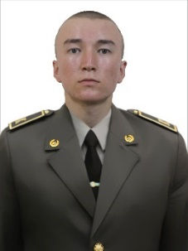 | 3 batalyon  6 vzvod  4 guruh
 | Soatov Muhriddin Hamdam o‘g‘li | 52510056300030 | 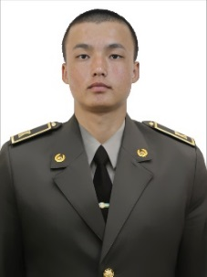 | 3 batalyon  6 vzvod  4 guruh
 | Sunnatillaev Boburxon Olimxonovich | 50601076570023 |  | 3 batalyon  6 vzvod  4 guruh
 | Temirov Ilimdor Nizom o‘g‘li | 50611056090115 | 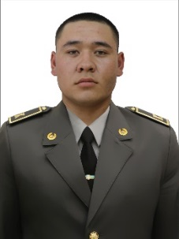 | 3 batalyon  6 vzvod  4 guruh
 | Tog‘ayev Davron Abdurashid o‘g‘li | 52410066330013 | 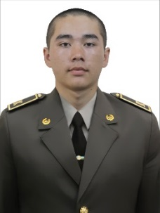 | 3 batalyon  6 vzvod  4 guruh
 | Usmonov Karnronbek Elyor o‘g‘li | 51706065630021 | 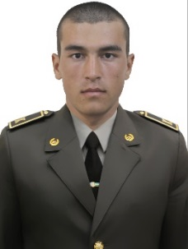 | 3 batalyon  6 vzvod  4 guruh

5-KURSANTLAR VZVODI KOMANDIRI
kapitan
Z.Abdusalomov

